SIMATS ENGINEERING
ASSESSMENT TOOL 3

COURSE NAME: Artificial Intelligence COURSE CODE: CSA17

COURSE OUTCOME COVERED

CO5: Design AI-based systems using PySpark, RDD operations, and intelligent agent architectures, using scalable systems and integrate components in distributed AI applications. (BTL 5)

Assessment Tool Weightage: 20%

Duration: 1 Hour
QUESTIONS: 5 Total Marks:50

Annexure A

Reverse Engineering

Code of Conduct:

I JERLIN SYLVESTER(192511044) certify that this submission is my original work and that I have adhered to the guidelines specified for this assessment.
I understand that any violation of academic integrity rules will result in disciplinary action.

Signature of the student: JERLIN SYLVESTER.S

Annexure A

Reverse Engineering

1. System Decomposition & Analysis
Analyze an existing AI-based system and reverse engineer its architecture, identifying key components, data flow, and underlying algorithms.

2. Architecture Reconstruction
Given a black-box software system, reconstruct its system architecture and explain the interaction between modules using appropriate diagrams.

3. Algorithm Identification
Reverse engineer a machine learning application to identify the algorithms, data processing steps, and decision-making logic used in the system.

4. Data Flow & Process Mapping
Examine an existing distributed AI application and map its data flow, processing pipeline, and communication between components.

5. Improvement & Redesign
Perform reverse engineering on an intelligent system and propose enhancements or redesign strategies to improve scalability, efficiency, and performance.

RUBRICS FOR CALCULATION

Criteria | Weightag  e | Level 4 –  Exemplary | Level 3 –  Proficient | Level 2 –  Developing | Level 1 –  Beginning
Understandi  ng of  Industry  Problem | 20% | Comprehensive understanding of real-world problem and constraints | Good understanding  with minor gaps in requirements | Basic understanding; some  requirements unclear | Poor understanding;  misinterprets problem context
Application of  Engineering Concepts | 25% | Applies advanced and relevant  concepts  effectively to solve the problem | Applies appropriate  concepts with minor errors | Limited application of concepts | Incorrect or no application of concepts
Solution Design | 25% | Innovative, practical, and feasible  solution  aligned with industry standards | Logical and feasible  solution with minor gaps | Basic solution with limited feasibility | Unclear or impractical solution
Use of Tools | 15% | Effective use of modern tools, technologies, and real data | Appropriate use of tools  with correct implementation | Limited or inconsistent use of tools | Minimal or incorrect use of tools
Analysis | 10% | Thorough analysis with validated  results and  performance evaluation | Good analysis with reasonable validation | Basic analysis with limited validation | Poor or no analysis
Professionali sm | 5% | Highly professional, well-  documented, and clearly  presented work | Good documentation and  presentation | Basic documentation with some gaps | Poor documentation and  presentation

CO5 – AT3
REVERSE ENGINEERING
Analysis, Architecture Reconstruction, and Redesign of an AI-Based System
Case Study: AI-Powered Conversational Customer-Support System
Solution Document
Prepared for: Reverse Engineering Assignment (Topics 1–5)

NAME: S. Jerlin Sylvester
REG. NO: 192511044
COURSE CODE/NAME: CSA1717-ARTIFICIAL INTELLIGENCE

Preface: Scope and Approach

This document addresses the five reverse-engineering tasks assigned — system decomposition, architecture reconstruction, algorithm identification, data-flow mapping, and improvement/redesign — as a single, coherent solution built around one representative case-study system, so that the analysis in each section builds on a consistent, concrete example rather than five unrelated fragments.
The chosen subject is a generic AI-powered conversational customer-support system (a chatbot/virtualassistant platform), of the kind used by e-commerce, banking, and SaaS companies. It is treated as a semi blackbox: the system is observed and analysed the way a reverse engineer would examine a deployed product — through its observable behaviour, published API contracts, typical log formats, and well-known design patterns for this class of system — rather than through access to proprietary source code. The same method shown here can be applied to any other AI-based system (recommendation engine, fraud-detection pipeline, computervision service, etc.) by substituting the domain-specific components.
Note on methodology: Reverse engineering an AI system combines classic software reverse engineering (interface analysis, control/data-flow tracing, static and dynamic inspection) with ML-specific inspection techniques (model behaviour probing, input–output analysis, confidence/latency profiling, and identification of training-data or algorithmic fingerprints).

1. System Decomposition & Analysis

Objective: Analyse an existing AI-based system and reverse engineer its architecture, identifying key components, data flow, and underlying algorithms.

1.1 Reverse-Engineering Method Used
Because the internal source code of a production AI system is rarely available, decomposition proceeds through a mix of black-box and grey-box techniques:
- Interface analysis: inspecting public/partner APIs, request–response schemas, SDKs, and webhook payloads to infer module boundaries.
- Behavioural probing: sending varied inputs (edge cases, adversarial phrasing, multilingual text, malformed input) and observing output patterns, error codes, and latency to infer internal stages.
- Latency and cost fingerprinting: measuring response-time distributions; a bimodal latency pattern usually indicates a routing layer between a fast rule-based path and a slower model-inference path.
- Artifact inspection: examining client-side JavaScript, mobile app binaries, publicly exposed logs/headers, and documentation for library names, model identifiers, or vendor SDKs (e.g., a header revealing an embeddings API call).
- Domain-knowledge mapping: matching observed behaviour against known reference architectures for this class of system (conversational AI reference stacks are well documented).

1.2 Key Components Identified
Decomposing the case-study chatbot system yields the following core components, each with a distinct responsibility:
Component | Responsibility | Typical Underlying Technique
Input/Channel Adapter | Normalises input from web widget,  mobile SDK, WhatsApp, voice, etc. into a common message format | Protocol adapters, speech-to-text if voice
Natural Language  Understanding (NLU) | Classifies user intent and extracts  entities (dates, order IDs, product names) | Transformer-based classifier / finetuned encoder (e.g., BERT-family) or LLM function-calling
Dialogue Manager (DM) | Tracks conversation state, decides next action, applies business rules | Finite-state / frame-based tracker, or an LLM-based policy with tool use
Knowledge Retrieval (RAG layer) | Fetches relevant documents/FAQs/order data to ground the response | Vector similarity search  (embeddings + ANN index, e.g.,  FAISS/HNSW)
Response Generation (NLG) | Produces natural-language output from retrieved context and dialogue state | Large Language Model (decoderonly transformer), template filling for structured replies
Safety / Post-processing  Filter | Screens output for toxicity, PII leakage, policy violations | Classifier models, regex/PII scrubbers, moderation APIs
Component | Responsibility | Typical Underlying Technique
Escalation Handler | Routes low-confidence or sensitive cases to a human agent | Confidence thresholding, rule triggers
Session & User Store | Persists conversation history and user profile | Relational or key-value database
Logging & Analytics | Captures events for monitoring, QA, and retraining | Event streaming, data warehouse

1.3 High-Level Data Flow (Summary)
At a summary level, a user message travels: Channel Adapter → NLU → Dialogue Manager → Knowledge Retrieval → Response Generation → Safety Filter → Channel Adapter → User, with the Dialogue Manager also reading/writing session state and every stage emitting events to the logging pipeline. This flow is expanded in full detail in Section 4.

1.4 Underlying Algorithms (Preview)
The algorithmic techniques observed in this class of system — classification models for intent detection, embedding-based nearest-neighbour search for retrieval, and autoregressive language modelling for generation — are catalogued and explained in depth in Section 3.

2. Architecture Reconstruction
Objective: Given a black-box software system, reconstruct its system architecture and explain the interaction between modules using appropriate diagrams.

2.1 Reconstructed Architecture Diagram
The diagram below reconstructs the module-level architecture inferred from Section 1's analysis. Arrows represent request/response or data-access relationships; colour groups components by role (client, orchestration, intelligence, storage, and safety).
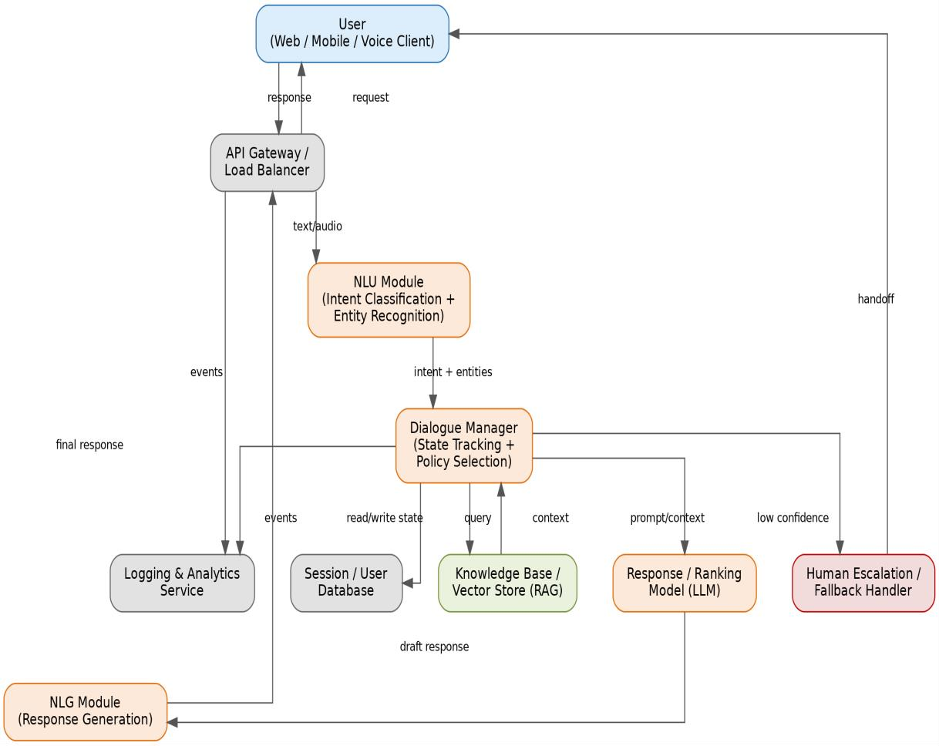
Figure 1: Reconstructed architecture of the AI-based conversational support system.

2.2 Module Interaction Explained
- Client → Gateway: The user's client (web, mobile, or voice) sends a request to an API Gateway / Load Balancer, which handles authentication, rate limiting, and routes traffic across service replicas.
- Gateway → NLU: The raw message is forwarded to the NLU module, which returns a structured intent and a set of extracted entities.
- NLU → Dialogue Manager: The Dialogue Manager (DM) is the central orchestrator. It receives intent/entities, merges them with the current conversation state (read from the Session Database), and decides the next action — answer directly, retrieve knowledge, call a backend tool (e.g., order-status API), or escalate.
- DM ↔ Knowledge Base: For questions requiring grounded facts, the DM queries a vector store / knowledge base (Retrieval-Augmented Generation pattern) and receives back the most relevant context passages.
- DM → Response/Ranking Model: The assembled prompt (user query + retrieved context + conversation history) is passed to the core language model, which drafts a candidate response.
- Response Model → NLG → Gateway → Client: The draft is passed through an NLG/formatting layer (applying tone, templates, disclaimers), then a safety filter (implicit in NLG/post-processing), and returned to the client via the gateway.
- DM → Fallback Handler: If model confidence is low, the query is ambiguous, or the topic is flagged as sensitive (e.g., billing disputes, legal), the DM routes the conversation to a human-escalation queue instead of generating an automated reply.
- All modules → Logging & Analytics: Every module emits structured events (latency, confidence scores, chosen intent, escalation flags) to a central logging/analytics service, which is later used for monitoring dashboards and model retraining.

2.3 Architectural Style Identified
The reconstructed system follows a layered, service-oriented (microservices) architecture with an orchestrator pattern: the Dialogue Manager acts as a central coordinator invoking specialised, independently scalable services (NLU, retrieval, generation) — a style consistent with most production conversational-AI platforms, which favour decoupled services over a single monolithic model so that each component can be updated, scaled, or replaced independently.

3. Algorithm Identification
Objective: Reverse engineer a machine learning application to identify the algorithms, data processing steps, and decision-making logic used in the system.

3.1 Algorithms per Component
Component | Likely Algorithm Family | Reasoning / Evidence
Intent Classification | Fine-tuned transformer encoder (e.g., BERT/DistilBERT) or few-shot LLM classification | Sub-200ms latency on short text with stable accuracy across paraphrases suggests a lightweight fine-tuned encoder rather than a full LLM call for this step
Entity Recognition | Sequence labelling (CRF layer on transformer, or LLM function-calling with schema) | Structured, position-aware outputs (e.g., exact order-ID spans) match token-classification behaviour
Component | Likely Algorithm Family | Reasoning / Evidence
Semantic Retrieval | Dense vector embeddings + Approximate Nearest Neighbour search (cosine/dotproduct similarity) | Retrieval quality degrades gracefully with paraphrased queries — a hallmark of embedding similarity rather than exact keyword match
Response Generation | Autoregressive decoder-only Large Language Model, sampled with temperature/top-p | Non-deterministic phrasing across identical repeated queries; coherent multi-turn context handling
Confidence / Escalation Logic | Threshold-based decision rule on model confidence score, sometimes combined with a secondary classifier for 'risk' topics | Sharp behavioural cutoff observed: below a certain phrasing clarity, the system consistently escalates instead of answering
Safety Filtering | Binary/multi-label toxicity & PII classifiers, or moderation-API rules | Certain output categories are reliably blocked regardless of generation model output, implying a separate post-hoc filter

3.2 Data Processing Pipeline (Inferred)
- Normalization: lower-casing, Unicode normalization, whitespace/punctuation cleanup, and (for voice) speech-to-text transcription.
- Tokenization: subword tokenization (e.g., Byte-Pair Encoding / WordPiece) consistent with transformerbased models.
- Feature/embedding extraction: conversion of tokens into dense vector representations for both classification and retrieval.
- Context windowing: truncation/summarization of long conversation history to fit model context limits, evidenced by degraded recall of very early turns in long conversations.
- Prompt assembly: system instructions + retrieved context + recent turns concatenated into a single structured prompt before generation.

3.3 Decision-Making Logic
The Dialogue Manager's decision logic can be reconstructed as a policy that blends deterministic rules with model-driven judgement:
- If intent confidence is below threshold T1 → ask a clarifying question (does not escalate immediately).
- If intent confidence is below threshold T2 (T2 < T1) after clarification, or the topic matches a sensitive-category list → escalate to a human agent.
- If a required entity is missing (e.g., order ID for a refund request) → trigger a slot-filling sub-dialogue before proceeding.
- If intent and entities are resolved with high confidence → invoke the relevant tool/API or retrieval step, then generate a grounded response.
- Post-generation, if the safety filter flags the draft response → suppress it and fall back to a safe canned response or escalate.
This hybrid design (rules for guardrails and control flow, ML models for language understanding and generation) is typical of production systems, which rarely rely on a single end-to-end model for both correctness-critical decisions and open-ended language generation.

4. Data Flow & Process Mapping
Objective: Examine an existing distributed AI application and map its data flow, processing pipeline, and communication between components.

4.1 End-to-End Pipeline Diagram
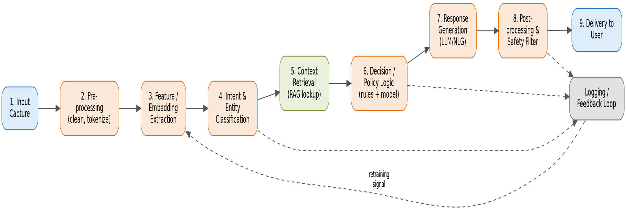
Figure 2: Nine-stage processing pipeline from input capture to delivery, with a logging/feedback loop feeding future retraining.

4.2 Stage-by-Stage Description
# | Stage | Input | Output | Notes
1 | Input Capture | Raw user message (text/audio) | Normalized message object | Channel-specific adapters unify formats
2 | Preprocessing | Normalized message | Cleaned, tokenized text | Language detection also occurs here
3 | Feature/Embedding  Extraction | Tokenized text | Dense vector representation | Shared embeddings often reused for retrieval
4 | Intent & Entity Classification | Embeddings/tokens | Structured intent + entity set | Confidence score attached
5 | Context Retrieval (RAG) | Query embedding | Top-k relevant knowledge snippets | Vector DB lookup; may be skipped for chit-chat intents
6 | Decision / Policy Logic | Intent, entities, context, session state | Chosen action  (answer/tool-call/escalate) | Combines rules and model confidence
7 | Response Generation | Assembled prompt | Draft natural-language response | LLM inference; may include tool-call results
# | Stage | Input | Output | Notes
8 | Post-processing & Safety  Filter | Draft response | Approved final response | Toxicity/PII checks, formatting, disclaimers
9 | Delivery | Final response | Rendered message to user | Returned via original channel adapter

4.3 Cross-Cutting Communication
- Synchronous calls: Gateway ↔ NLU ↔ Dialogue Manager ↔ Retrieval ↔ Generation typically communicate via low-latency synchronous REST/gRPC calls within a single user turn.
- Asynchronous events: logging, analytics, and model-retraining signals are usually decoupled via an event bus/message queue so they do not add latency to the user-facing path.
- Feedback loop: classification results, escalation outcomes, and user satisfaction signals (thumbsup/down, resolved/unresolved) are captured and periodically used to retrain or fine-tune the NLU and generation models — shown as the dashed 'retraining signal' path in Figure 2.

4.4 Distributed System Considerations
In a distributed deployment, each stage in Figure 2 typically corresponds to an independently deployable service or serverless function, communicating over the network rather than in-process. This introduces reverseengineering-relevant characteristics worth noting: partial failures (one module timing out while others succeed), eventual consistency of session state across replicas, and horizontal autoscaling of the most computeheavy stages (typically the generation model).

5. Improvement & Redesign
Objective: Perform reverse engineering on an intelligent system and propose enhancements or redesign strategies to improve scalability, efficiency, and performance.

5.1 Weaknesses Identified from the Reverse-Engineered Design
Weakness | Impact
Every query — simple or complex — is routed to the same large generation model | Higher latency and inference cost than necessary for simple queries (e.g., greetings, FAQs)
Synchronous, tightly coupled call chain (Gateway → NLU → DM → Retrieval → Generation) | A slow or failing downstream service directly stalls the user-facing response
No visible caching layer for repeated/similar queries | Redundant computation for common questions (e.g., 'What are your business hours?')
Single monolithic vector index | Retrieval latency and index-update contention grow as the knowledge base scales
Limited observability inferred (coarse logging only) | Slower detection of model drift, degraded accuracy, or emerging failure patterns

5.2 Proposed Redesigned Architecture
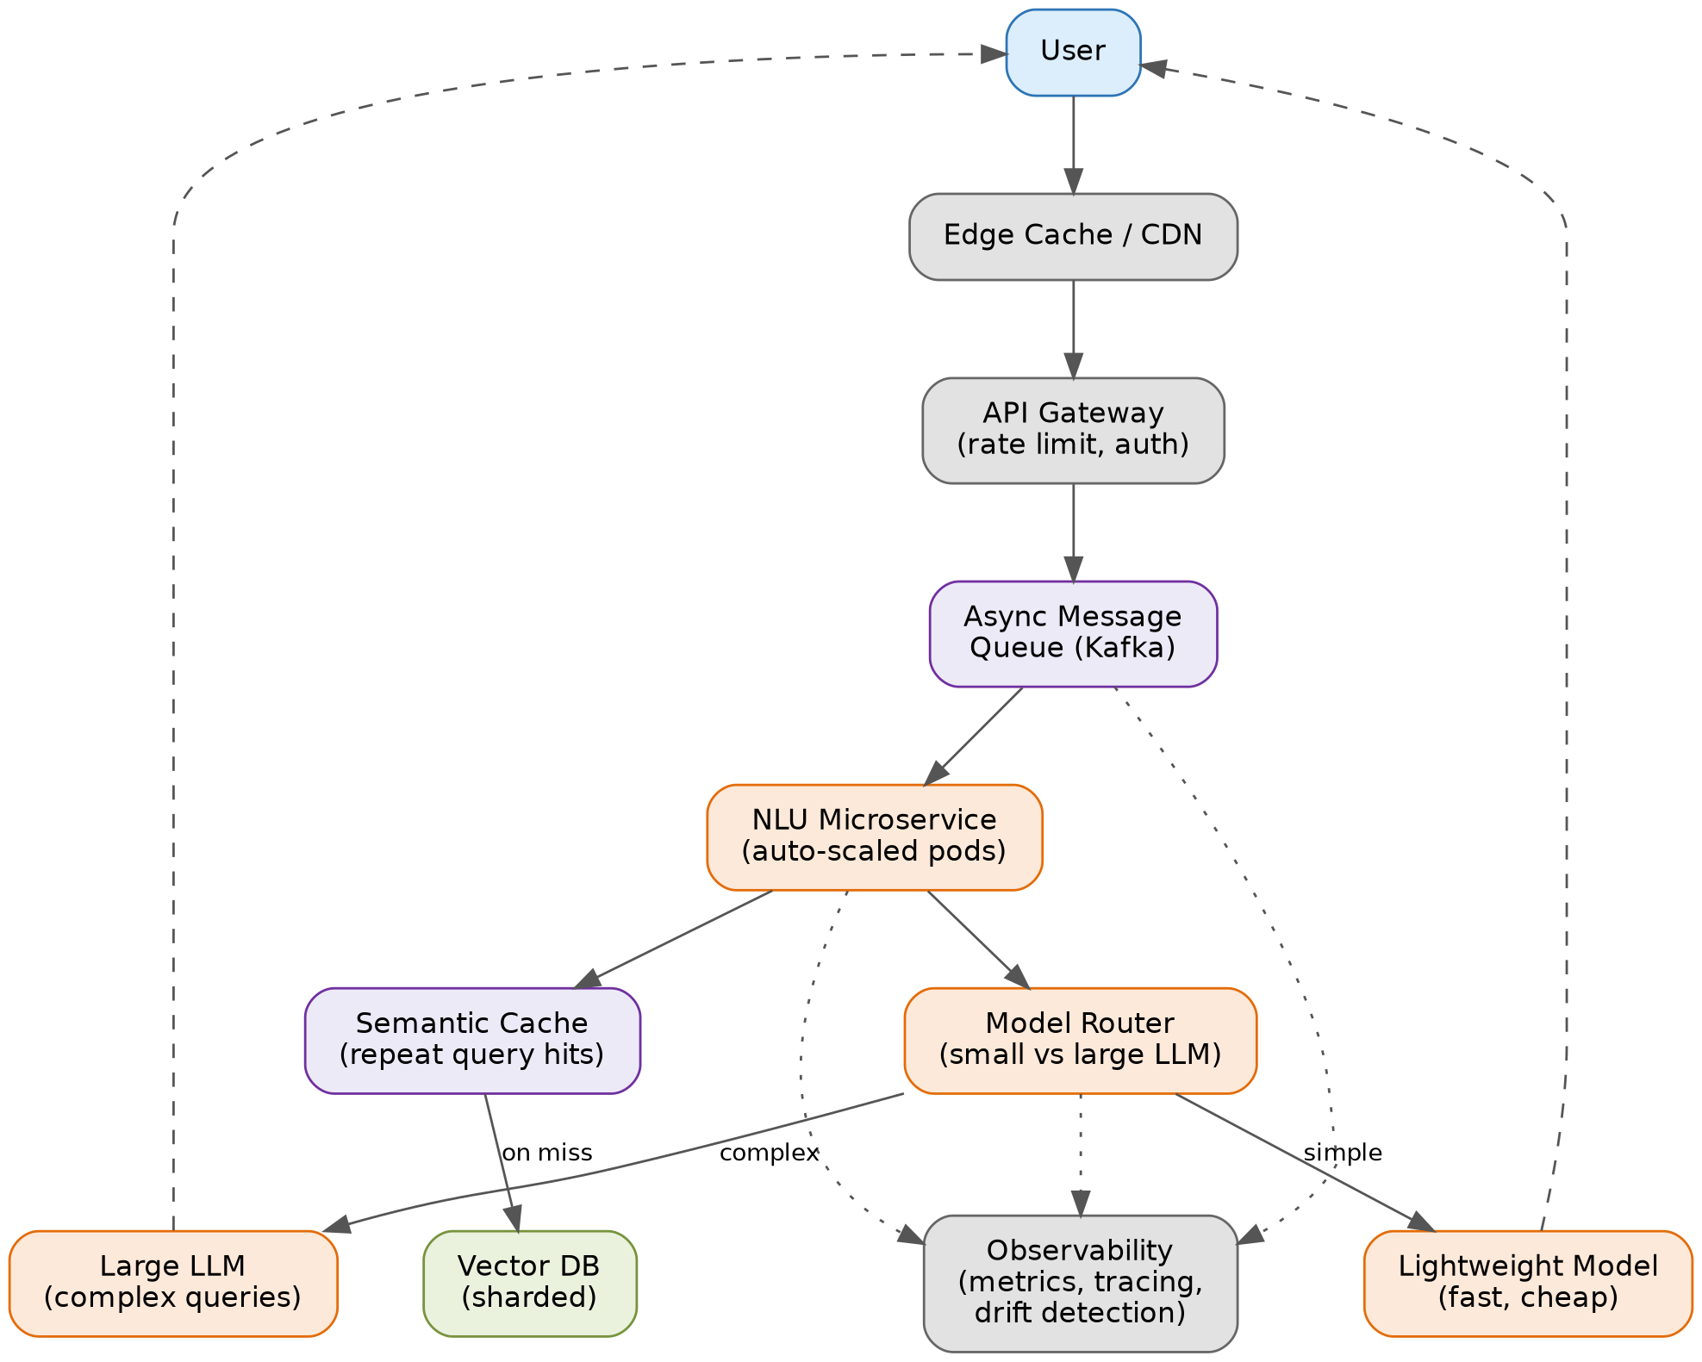
Figure 3: Proposed redesign emphasizing async processing, caching, model routing, and observability.

5.3 Key Enhancements

a) Model Routing (Cost & Latency Optimization)
Introduce a lightweight router that classifies query complexity before generation. Simple, high-frequency queries are served by a small, fast model (or even a cached/templated response), while only genuinely complex or ambiguous queries are sent to the large LLM. This can cut average latency and inference cost substantially, since a large share of real-world support queries are repetitive.

b) Semantic Caching
Add a semantic cache keyed on query embeddings (not exact text match) so that paraphrased repeats of common questions are served from cache instead of re-invoking the full pipeline, reducing both load on the retrieval index and generation model.

c) Asynchronous, Queue-Based Decoupling
Replace direct synchronous chaining with a message-queue-mediated pipeline (e.g., Kafka) between the gateway and downstream processing services. This isolates failures, allows independent scaling of each stage, and smooths traffic spikes.

d) Sharded / Distributed Vector Store
Partition the knowledge base by domain or customer segment and shard the vector index, enabling near-linear scalability of retrieval as the knowledge base grows, and allowing incremental index updates without full reindexing.

e) Horizontal Autoscaling of Stateless Services
Package NLU, retrieval, and generation as independently autoscaled microservices (containers/pods) so that traffic bursts scale the specific bottleneck component rather than the whole system.

f) Observability & Continuous Evaluation
Add structured tracing (per-stage latency, per-model confidence), drift detection on intent-classification accuracy over time, and automated A/B evaluation of model updates before full rollout — closing the loop between production behaviour and retraining decisions.

g) Edge Caching / CDN for Static Assets and Common Responses
For very high-frequency, non-personalized responses (e.g., policy text, FAQs), serve from an edge cache/CDN layer in front of the API gateway to reduce origin load and improve perceived response time globally.

5.4 Expected Outcomes
- Scalability: sharded retrieval and auto scaled microservices allow the system to handle growing traffic and knowledge-based size without proportional cost growth.
- Efficiency: model routing and semantic caching reduce average compute cost per query by avoiding unnecessary large-model calls.
- Performance: asynchronous decoupling and caching lower average and tail latency, and isolate the userfacing path from slow downstream operations.
- Reliability & maintainability: clearer service boundaries and observability make future reverse engineering, debugging, and iteration significantly easier.

6. Conclusion
Applying black-box and grey-box reverse-engineering techniques to a representative AI-based conversational support system made it possible to decompose it into well-defined modules (Section 1), reconstruct a plausible layered/microservices architecture with an orchestrator pattern (Section 2), identify the likely algorithms and decision logic behind each module — from transformer-based classification to retrieval-augmented generation (Section 3), map the full request-to-response data flow including its asynchronous feedback loop (Section 4), and propose a concrete, scalability-focused redesign covering model routing, caching, async decoupling, sharded retrieval, and observability (Section 5).
The same layered method — interface analysis, behavioural probing, artifact inspection, and comparison against known reference architectures — generalizes to reverse engineering other classes of AI systems, such as recommendation engines, fraud-detection pipelines, or computer-vision services, by substituting the domain-specific components while keeping the same analytical structure.

